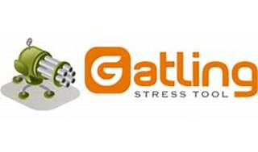

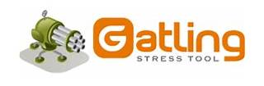

Explore

**Gatling** is a **load testing tool** designed for **DevOps** and **Continuous Integration**. [It helps organizations identify bottlenecks and ensure website stability under traffic load through test automation1](https://gatling.io/)[2](https://www.g2.com/products/gatling/reviews).

Here are **five free reference links** where you can learn more about Gatling:

1. [**Gatling Official Website**](https://gatling.io/): Start with the official documentation and explore Gatling’s features and benefits[1](https://gatling.io/).
2. [**Introduction to Gatling**](https://www.swtestacademy.com/introduction-gatling/): Learn about Gatling’s architecture and get started with load testing using this tutorial[3](https://www.swtestacademy.com/introduction-gatling/).
3. [**Gatling Tutorial: Getting Started**](https://www.softwaretestinghelp.com/gatling-tutorial/): Dive into installation, execution, and understanding HTML-based Gatling reports[4](https://www.softwaretestinghelp.com/gatling-tutorial/).
4. [**Performance Testing using Gatling - Beginner Level**](https://www.udemy.com/course/performance-testing-using-gatling/): A Udemy course covering Gatling setup, scripting, and test reporting[5](https://www.udemy.com/course/performance-testing-using-gatling/).
5. [**Gatling Academy**](https://academy.gatling.io/): Master Gatling through modules that guide you from basics to creating load testing frameworks[6](https://academy.gatling.io/).

Happy learning! 🚀